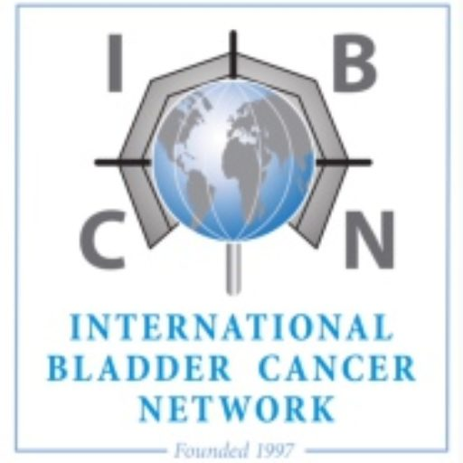

**The International Bladder**

**Cancer Network (IBCN) e.V.**

**IBCN Exchange Grant for Early-career Bladder Cancer Investigators**

#### **1. Overview**

The International Bladder Cancer Network (IBCN) Exchange Grant supports early-career investigators engaged in bladder cancer research by facilitating short-term research exchanges with IBCN-affiliated laboratories or research groups worldwide. The program is open to PhD students, postdoctoral researchers, and assistant professors or equivalent junior faculty positions. By encouraging scientific exchange, skill development, and collaboration, the Exchange Grant aims to foster both individual career development and the long-term sustainability of IBCN.

#### **2. Objectives**

* Facilitate **hands-on training and knowledge exchange** in bladder cancer research.
* Strengthen **collaborations** between IBCN-affiliated research groups.
* Support the **career development** of early-career investigators by broadening their research experience.
* Enhance international research networks and encourage **multidisciplinary collaboration**.
* Promote the acquisition of novel techniques and insights that advance research on any aspect of bladder cancer including collaborative exchanges with other research groups.
* Encourage the dissemination of knowledge gained during these exchanges through IBCN meetings, the member portal or peer support to maximize impact for the broader community.

#### **3. Eligibility Criteria**

* Open to **early-career investigators, including PhD students, postdoctoral researchers** (within 6 years of receiving their doctorate)**, and assistant professors,** actively conducting bladder cancer research.
* The applicant must be an active IBCN member.
* The host investigator is recommended to be an active member of IBCN, however, this is not mandatory.
* Applicants must provide a justification for the intended exchange by demonstrating how it benefits their research and career development.

#### **4. Exchange Grant Duration & Funding**

* Duration: flexible based on project needs but duration is expected to be between 2 weeks and 2 months.
* **Funding support:** **€5,000 and costs for travel (see details below)**

#### **5. Application Process**

1. **Application Submission**:
   * Complete the **IBCN Exchange Grant application form**
   * Include a **brief research plan** (max. 750 words) (objectives, methods, expected outcomes, scientific merit, and feasibility)
   * Include a brief description of expected benefit for research and career development.
   * Include a brief description of the current status of collaboration between the research groups/labs of the applicant and host.
   * Include a **support letter from the home institution/supervisor** and a **confirmation/support letter from the host supervisor**.
   * Include a current CV.
   * Include a list of expected costs associated with the exchange (**travel, accommodation and other related expenses). Provided support will be based on this budget.**
2. **Review and Selection**:
   * Applications will be evaluated by an **IBCN review panel** based on scientific merit, feasibility, and potential impact for the investigators, the IBCN and the bladder cancer research field.
   * Preference will be given to projects fostering novel as well as likely sustainable **collaborations**.
3. **Notification and Implementation**:
   * Every effort will be made to notify selected applicants within **8 weeks** of application submission.
   * It is expected that the exchange will be completed within **12 months** of receiving the grant (unless there are travel associated or logistical delays, about which the applicant must notify the IBCN in advance).

#### **6. Post-Exchange Requirements**

* Submission of a **brief report (1–2 pages)** summarizing key learnings and outcomes (will be shared on the IBCN member portal).
* Presentation of learning experience and research findings at the **IBCN annual meeting in the year following the completion of exchange**.
* Acknowledgment of **IBCN support in any knowledge dissemination initiatives (conference presentations, community events or research publications)**.

#### **7. Contact & Further Information**

For inquiries or to submit an application, please contact: info@ibcnweb.com